

**User Interface Considerations for littleBits Module Design**

"Make everything as simple as possible, but not simpler."

-Albert Einstein

The key to designing a good interface for a littleBits module is to keep it simple. It can be tempting to add features and extend functionality but our most highly regarded feature is the ability to take something sophisticated and make it simple and intuitive. It is more important to provide immediate control than absolute control. When designing the interface for a module, imagine that the user will receive no explanation on how the module works, or if they do, it would be one or two sentences of explanation. Keeping this in mind will result in an interface that can figured out by the user while using the module.

Before you embark on designing your own module, please take some time and study the modules that littleBits has already created. We strive to keep a uniform look, feel, and user experience to our system and by observing our established practices, you can better create a design that conforms and integrates with the littleBits library.

Here are a few tips for module design:

* Use our pre made module templates. These are the approved module sizes and dimensions. Modules that do not conform to these dimensions will not be accepted. If you have a module idea that cannot conform to these templates, please contact us at bitlab@littlebits.cc to discuss your options.

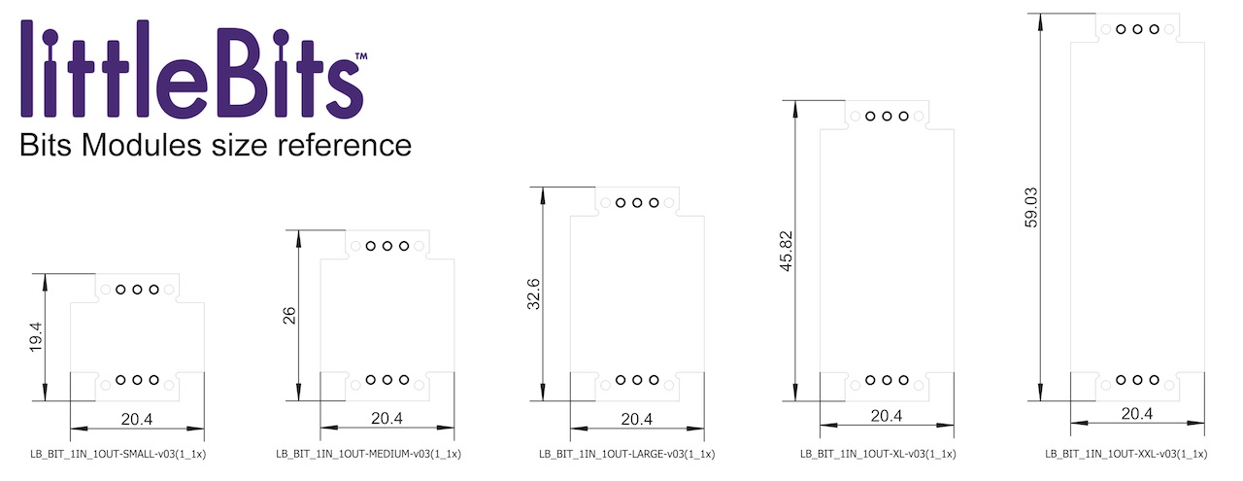

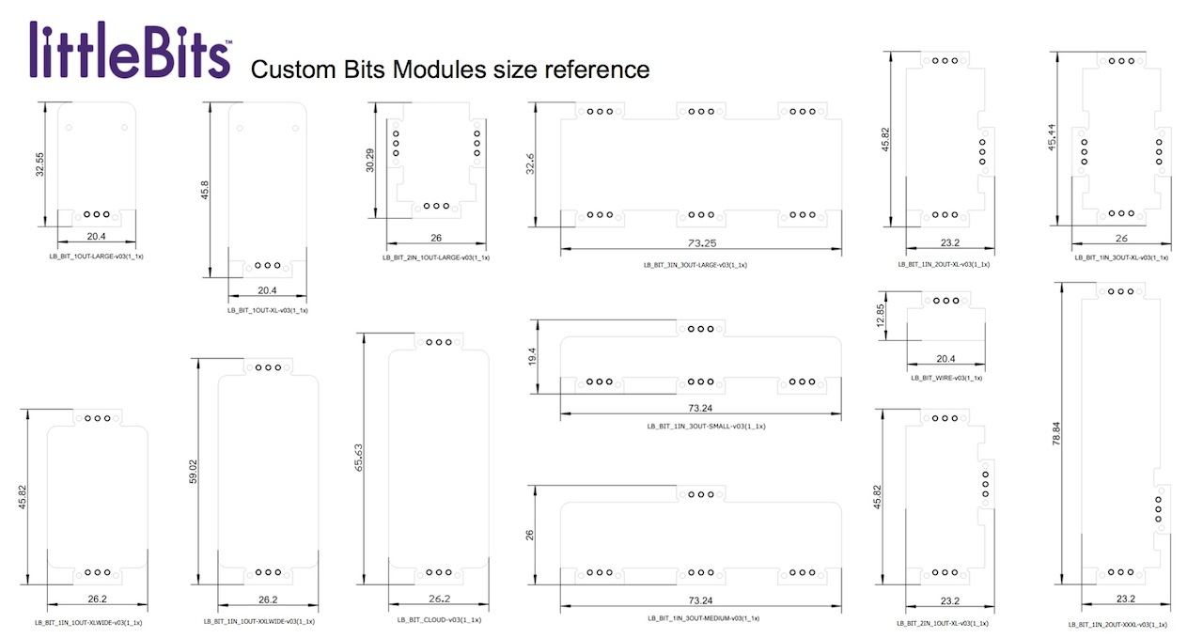

* When possible, please use components from our preferred parts list and Eagle library. In some cases substitutions will be allowed but if we regularly use a similar component in our designs, they will not. This is not only to make manufacturing easier and more cost effective, it also maintains a unified look and feel across all modules.
* Try to fit your design in the smallest size template possible. In use, littleBits modules will be assembled with many others and in order to keep the overall circuit assembly as small as it can be, it is preferred that each circuit be laid out as tightly as it can be. In many cases, this will make the circuit more difficult to lay out but it improves the over experience of the system. Exceptions for this include electrical optimization for a circuit or clarity of the interface.
* When placing components on the top side of the PCB, only place components that are a part of the user interface, i.e. LEDs, switches, potentiometers, sensors, etc. These should be placed on the top side and all other components should be kept on the bottom layer. Some exceptions are permitted but this should try to be followed as closely as possible.
* If there are multiple interface elements the top of a PCB, ones that get physical manipulated by the user should be placed on the lower half of the PCB so that they are closer to the user.

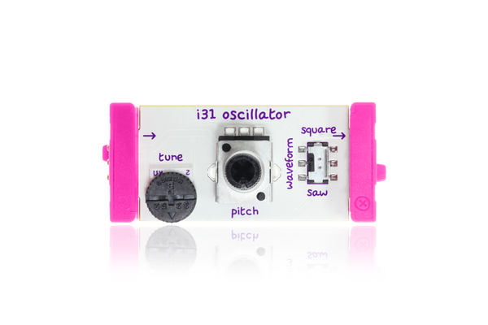

*Only interface elements are on the top side*

* Unlike most electronic products,with littleBits the user has full visibility of the circuit board. Because of this, layouts should should be as neat as possible. This means keeping components evenly spaced, symmetrical, and placed in line with the X and Y axis where possible. This is true for both the top and bottom side of the PCB.

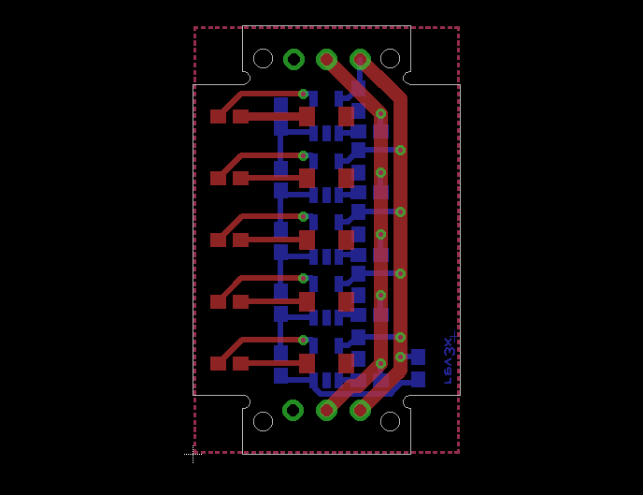

*Components are placed neatly and on the same planes*

* Leave room for required silkscreen elements in your layout. The module number and name must be present on the top layer of the board. Please reference existing module designs for approved positioning.
* Top side component placement should be done according to the function of the interface element. For example, a switch that selects what sort of signal is output from the module (AC or DC coupled for example) should be placed closer to the output bitSnap™ connector.
* All interface elements should be clearly labeled.
* A module should not contain more than one mode switch that pertains to a single function. Where at all possible, there should be a single mode switch that can select between 2, 3, or 4 modes of operation.
* Indicator LEDs should be used sparingly. If the LED included on the module does not provide required information for the use of the module, it should be omitted. The modular nature of littleBits encourages the use of other modules to indicate the state of the output of the module.
* Bottom side components cannot exceed 3mm in height. This will affect connection to our mounting boards.
* Aside from the mandatory elements such as module name, logos, etc., the silk screen layer should be left as clean as possible. Bounding boxes around components, unless absolutely necessary for manufacturing purposes, should not be included.
* Some of our templates feature multiple bitSnap™ connectors. Secondary inputs or outputs are positioned near the main input and output bitSnap™ connectors. The main input and output, positioned at either end of the module, should receive or send the signal from the previous module. The secondary inputs she be reserved for auxiliary inputs/outputs, triggers, resets, etc.
* Any components that are tethered to the PCB should observe good practices of strain relief.
* Since tantalum is a conflict mineral, avoid tantalum caps where possible.
* Use crystals instead of resonators as resonators have an unacceptable lead content. Where possible use an MCU’s internal oscillator to keep BOM cost down.